In the name of wisdom

Power electronic project

Dr.Abbas Ketabi

Amirhossein Shoaraye Nejati

(9521010039)

School of electrical and computer engineering

Kashan university

Winter 2019

Introduction:

A boost converter (step-up converter) is a DC-to-DC power converter that steps up voltage (while stepping down current) from its input (supply) to its output (load). It is a class of switched-mode power supply (SMPS) containing at least two semiconductors (a diode and a transistor) and at least one energy storage element: a capacitor, inductor, or the two in combination. To reduce voltage ripple, filters made of capacitors (sometimes in combination with inductors) are normally added to such a converter's output (load-side filter) and input (supply-side filter).

At first, before start simulation, we have to calculate state equations in ON/OFF mode:

A) if switch= off: $\frac{di_{L}}{dt}=\frac{E}{L}-\frac{r}{L}*i_{L}- \frac{V_{c}}{L}- \frac{r_{C}}{L*C}*[\frac{i_{L}}{M}-\frac{V_{c}}{R*M}]$

$$\frac{dV_{c}}{dt}= \frac{i_{L}}{M}- \frac{V_{c}}{R*M}$$

In a way we have: $M= \frac{C*R+r_{c}}{R}$

So we can achieve state equations for two above equations:

$$\begin{matrix}\frac{dV_{c}}{dt} \\ \frac{di_{L}}{dt}\end{matrix} = \begin{matrix}\frac{-1}{R*C^{2}+r_{C}*C} & \frac{1}{R*C^{2}+r_{C}*C} \\ \frac{-C^{3}*R+r_{c}*C^{2}+r_{C}}{L*C^{3}*R+R_{c}*C^{2}*L} & \frac{-r_{L}*C^{3}*R-r_{L}*r_{C}*C^{2}*L}{L*C^{3}*R+R_{c}*C^{2}*L}\end{matrix}$$

$\frac{V_{c}}{i_{L}} + \frac{0}{\frac{1}{L}} * E$

While: $y=V_{o}= \frac{r_{c}-C^{3}*R-C^{2}*L}{L*C^{3}*R+r_{c}*C^{2}*L} \frac{-r_{c}*R}{L*C^{3}*R+r_{c}*C^{2}*L} * \begin{matrix}V_{c} \\ i_{L}\end{matrix}$

B) If switch=on: $\begin{matrix}\frac{dV_{c}}{dt} \\ \frac{di_{L}}{dt}\end{matrix} = \begin{matrix}0 & 0 \\ 0 & \frac{-r_{L}}{L}\end{matrix} * \begin{matrix}V_{c} \\ i_{L}\end{matrix} + \begin{matrix}0 \\ \frac{1}{L}\end{matrix} * E$

While: $$y=V_{o}=V_{c}= \begin{matrix}1 & 0\end{matrix} * \begin{matrix}V_{c} \\ i_{L}\end{matrix}$$

After considering state equations in both modes, we will be able to calculate the working point, if we assume zero for input and derivations of states, we will have:

$$V_{c}=0 . i_{L}= 0$$

As we know this relation is working for boost converter:

$$D=1- \frac{V_{in}}{V_{out}}$$

So by considering working point, we assume:

$$Δi_{L}= \frac{V_{in}-\left(V_{ds}+I_{L}*R_{L}\right)}{L}*D*T_{s}$$

As we learnt in modern control, by this equation we can calculate system transfer function:

$$G_{s}=C*{\left(SI-A\right)}^{-1}*B+D$$

In mode: ON, we have: $$G_{s}= \frac{R*C*r_{C}}{\left(C*R*L+r_{c}*L\right)*S+C*R*r_{L}+r_{c}*r_{L}}$$

Then, if we use the amounts which mentioned for circuits elements in project statement table:



The final transfer function will be:

$$G_{s}= \frac{0/004}{\frac{75}{1000}*S+0/45 }$$

Also for $V_{out}=350v$ and $V_{in}=80v$, we have:

$$D=1-\frac{8}{35}=\frac{27}{35}$$

Now, we have to apply the converter schematic and the amounts we have achieved in MATLAB Simulink:

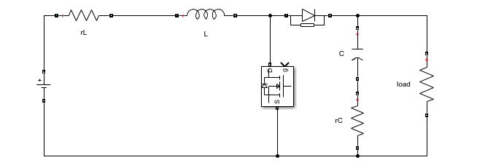

At first, we create a simple boost converter in which increase voltage without a controller (open loop):

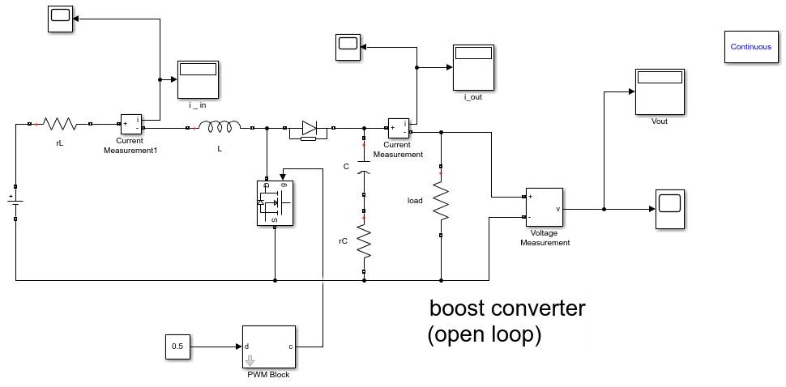

As it is obvious in this model, we only used a PWM block and a duty cycle block in order to trigger the MOSFET switch. Now we can look at input current and output voltage waveforms of this simulation:

A) Input current:

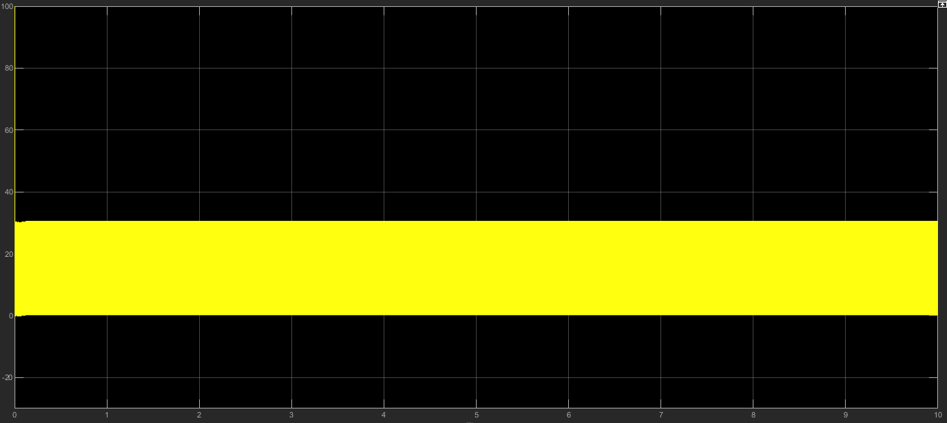

B) Output voltage:

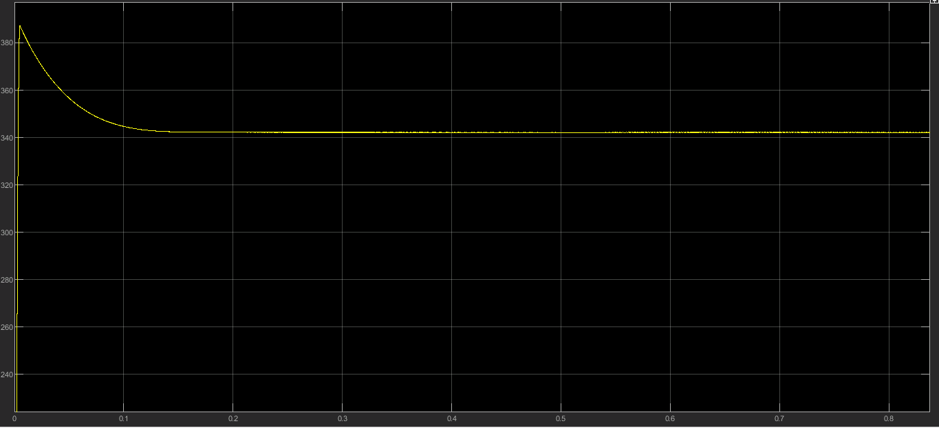

Also the maximum of the output voltage as it can be seen in the previous diagram is about 390 v.

After that, we coupled a designed PI controller to have a better output voltage (closed loop):

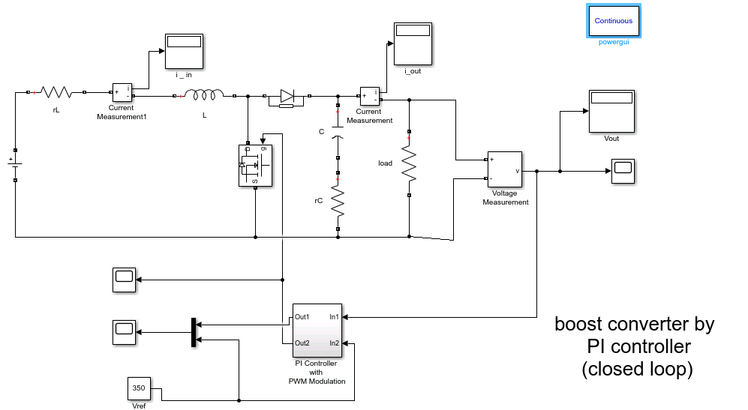

If we take a closer look to the schematic of this controller, it is vivid that we used a PWM generator and a relay in order to make the system follow our voltage reference :( it should be noticed we set clock pulse frequency on 20KHZ)

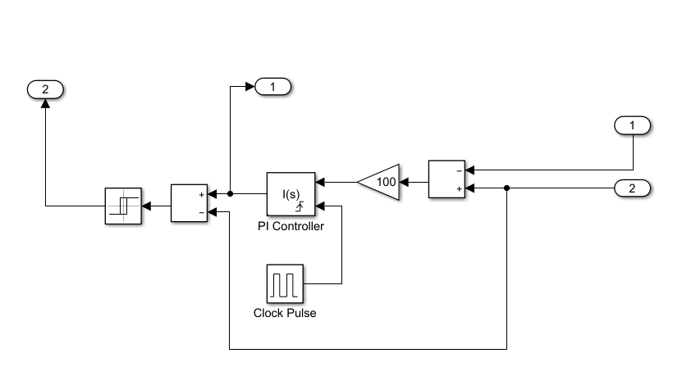

Now we use this circuit as a controller block which act as a feedback from output voltage.

Let’s observe properties of this closed loop model:

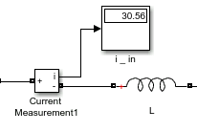A) Input current: B) output current:

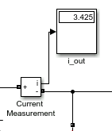   
C) Output voltage:

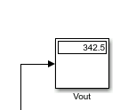

D) Output voltage waveform:

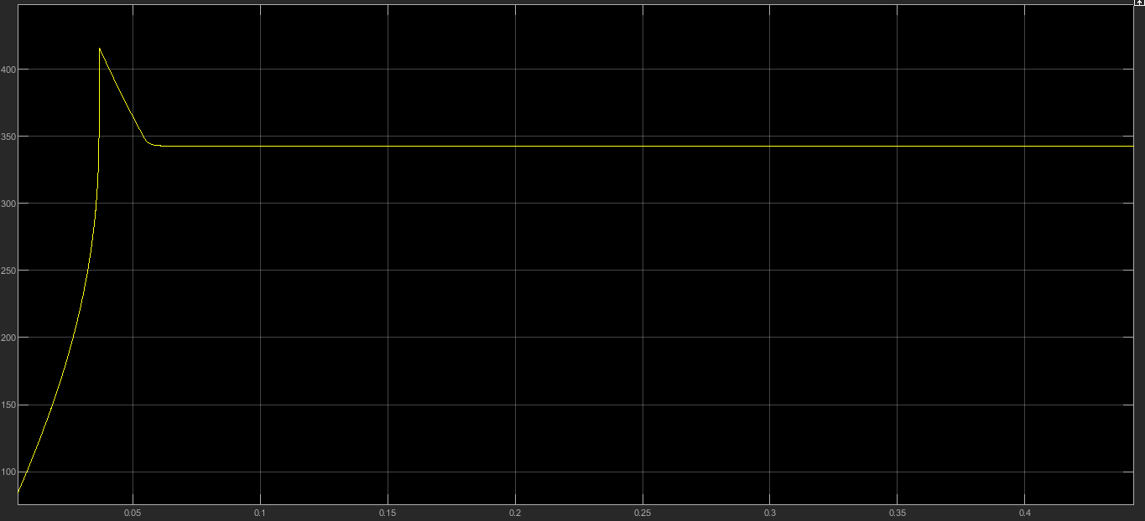

E) Control signal waveform:

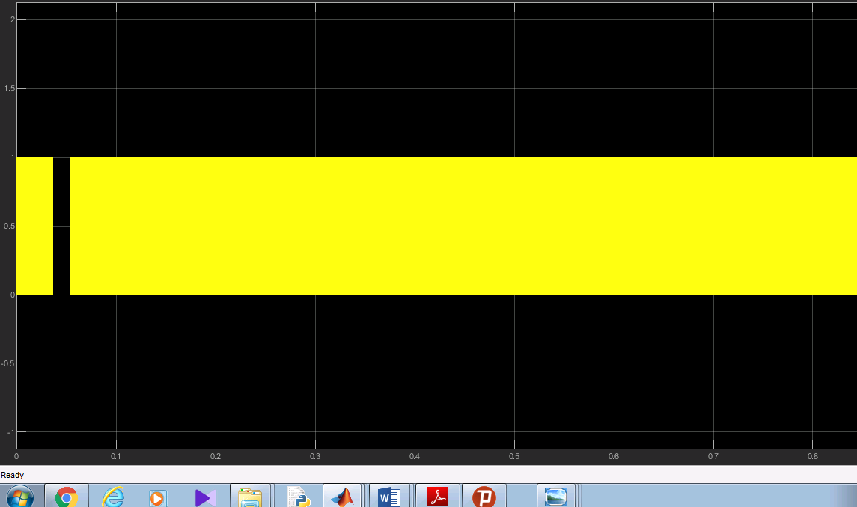

F) PI controller output waveform:

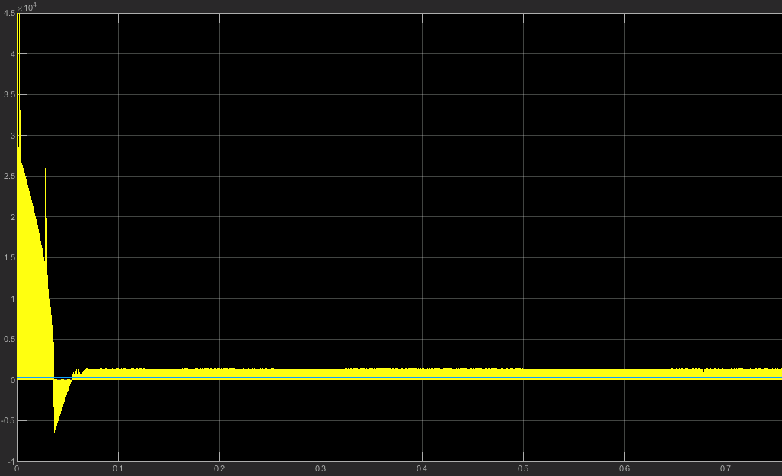

Finally, we want to apply some step changes in input voltage and reference voltage and investigate their effects:

For apply a step change in reference voltage and increase it from 350 to 380v, we have to add a step block and an add block to our model and also tune the step block:

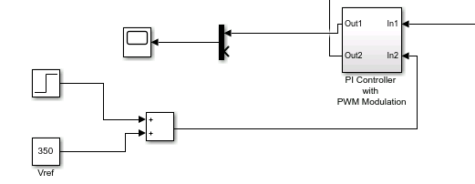

In this study the 30v step change has set on t=0.5s:

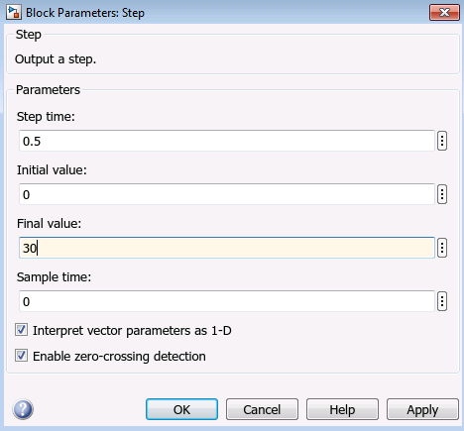

And then we can observe this change effect on the output voltage:

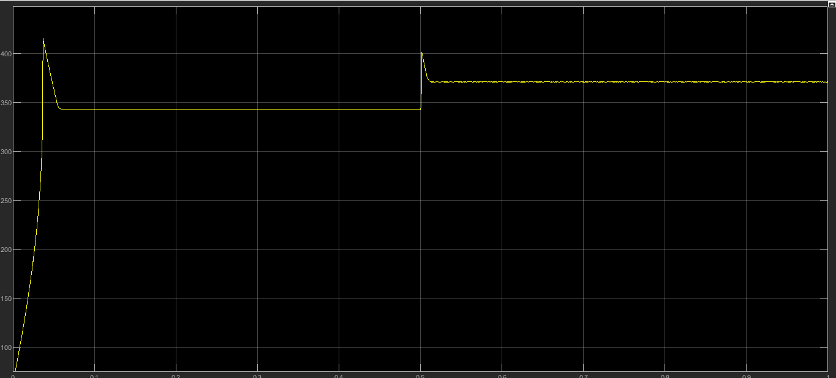

At last, at Vref=350, apply 20v step change to input voltage. For this action we used a step block and a controlled voltage source:

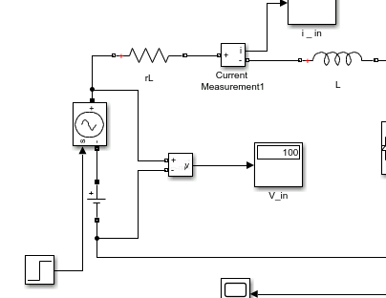

Let’s consider its affection on the output voltage waveform:

